**Making a Music Box with Micro:Bit**

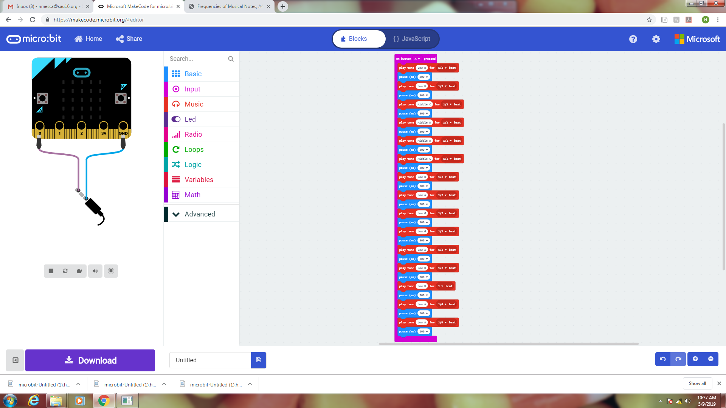In this project you will make a music box. When you press button A, it will play these notes. You may need to adjust the pause durations as well as the beat values. If things are correct, this should play Beethoven’s Ode To Joy. To hear the sound, you will need to hookup some headphones to pin 0 and Ground.

|  |  |  |
| --- | --- | --- |
| **Note (Frequency Hz)** | **Beats** | **Pause (ms)** |
| Low B (247) | 1/2 | 300 |
| Low B (247) | 1/2 | 300 |
| Middle C (262) | 1/2 | 300 |
| Middle D (294) | 1/2 | 300 |
| Middle D (294) | 1/2 | 300 |
| Middle C (262) | 1/2 | 300 |
| Low B (247) | 1/2 | 300 |
| Low A (220) | 1/2 | 300 |
| Low G (196) | 1/2 | 300 |
| Low G (196) | 1/2 | 300 |
| Low A (220) | 1/2 | 300 |
| Low B (247) | 1/2 | 300 |
| Low B (247) | 1 | 500 |
| Low A (220) | 1/4 | 200 |
| Low A (220) | 1/4 | 200 |